Chapter 19, Problem 82.

Use PSpice to rework Prob.19.31.

Chapter 19, Problem 31.

Determine the hybrid parameters for the network in Fig.19.88.

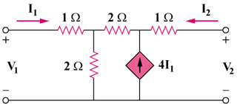

Figure 19.88
For Probs. 19.31 and 19.82.

